**FCIS Preparing Training**

We need:

Images:

* train folder (original images)
* Validation folder (original images)

Annotations:

* Annotations from training (json)
* Annotations from test (json)

Work Flow:

* Annotate images using Matlab
* Edit .yaml config file
* Run training

Completed:

* Annotation of ground truths in Matlab
* Getting the code to work with our dataset

Currently working on:

* Cuda issues
* Verify annotations

**JSON Format**

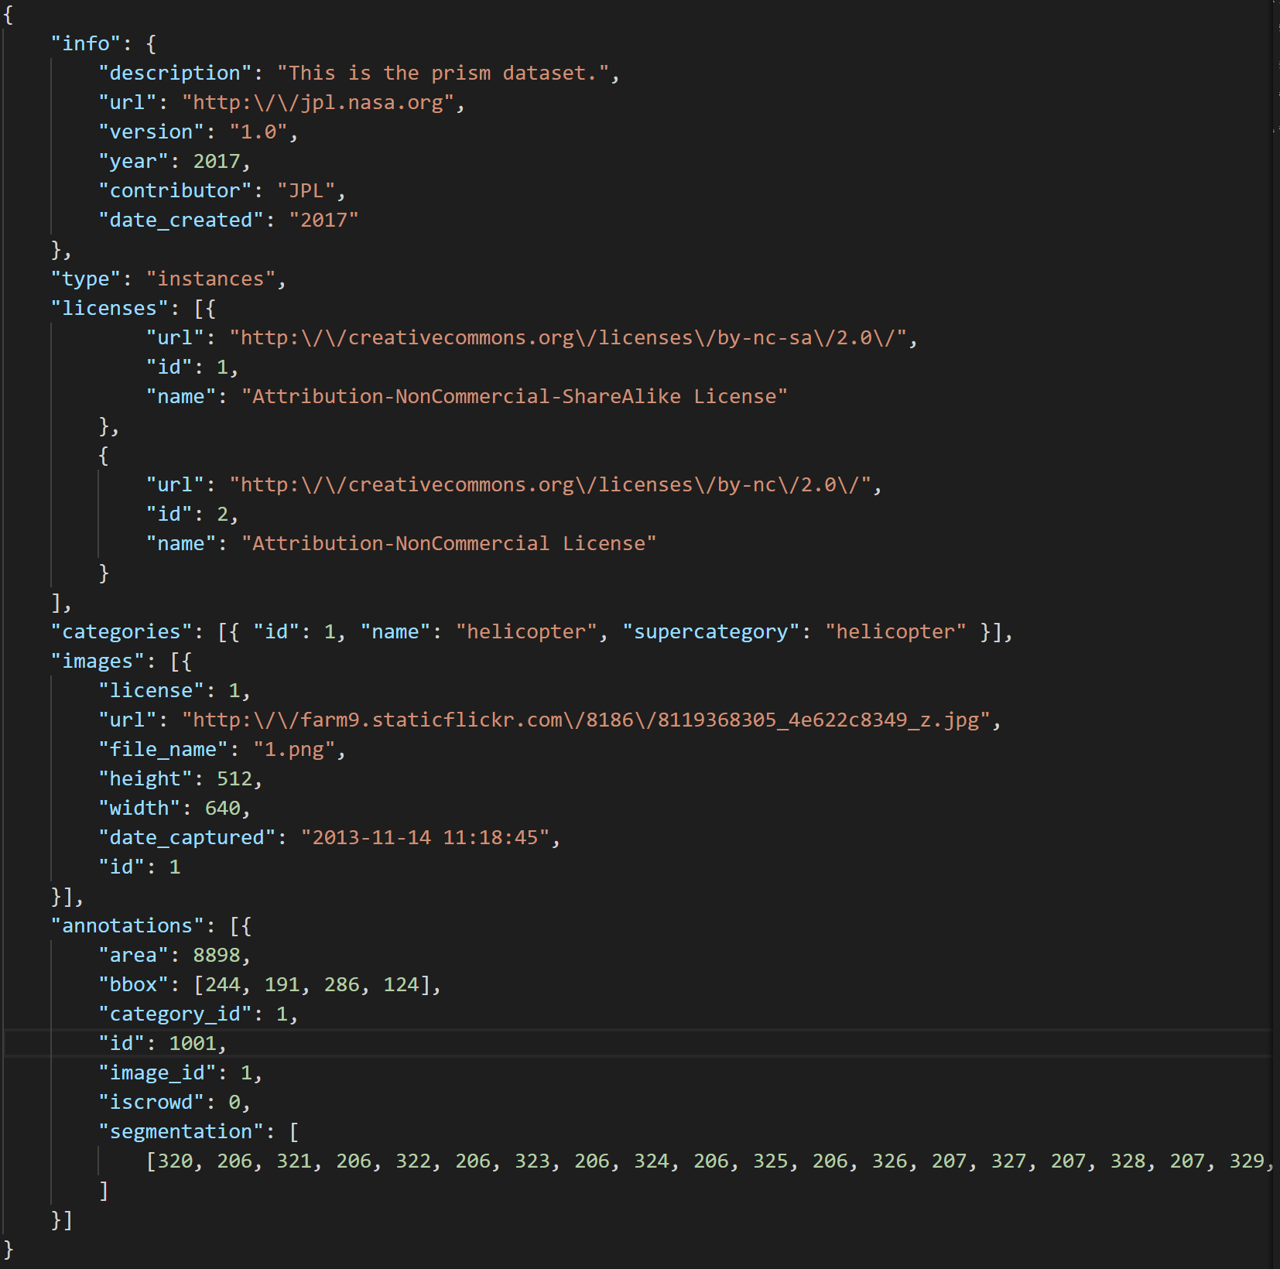

MatLab Code for Annotation Generation:

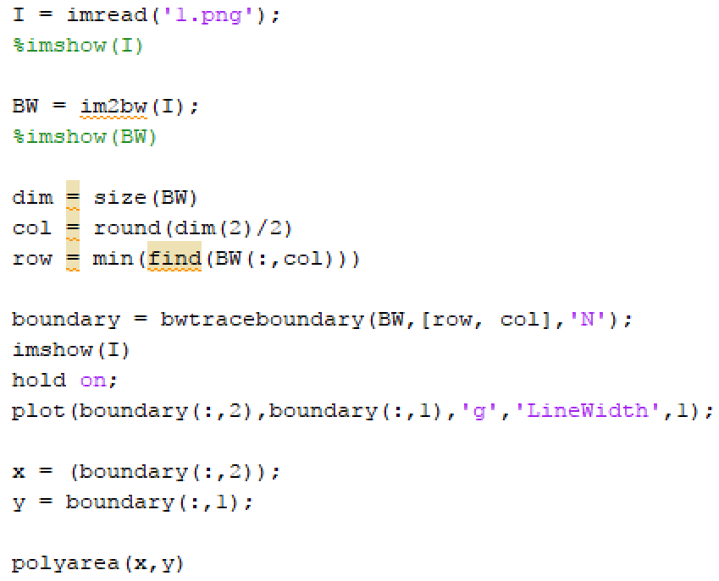

Output:

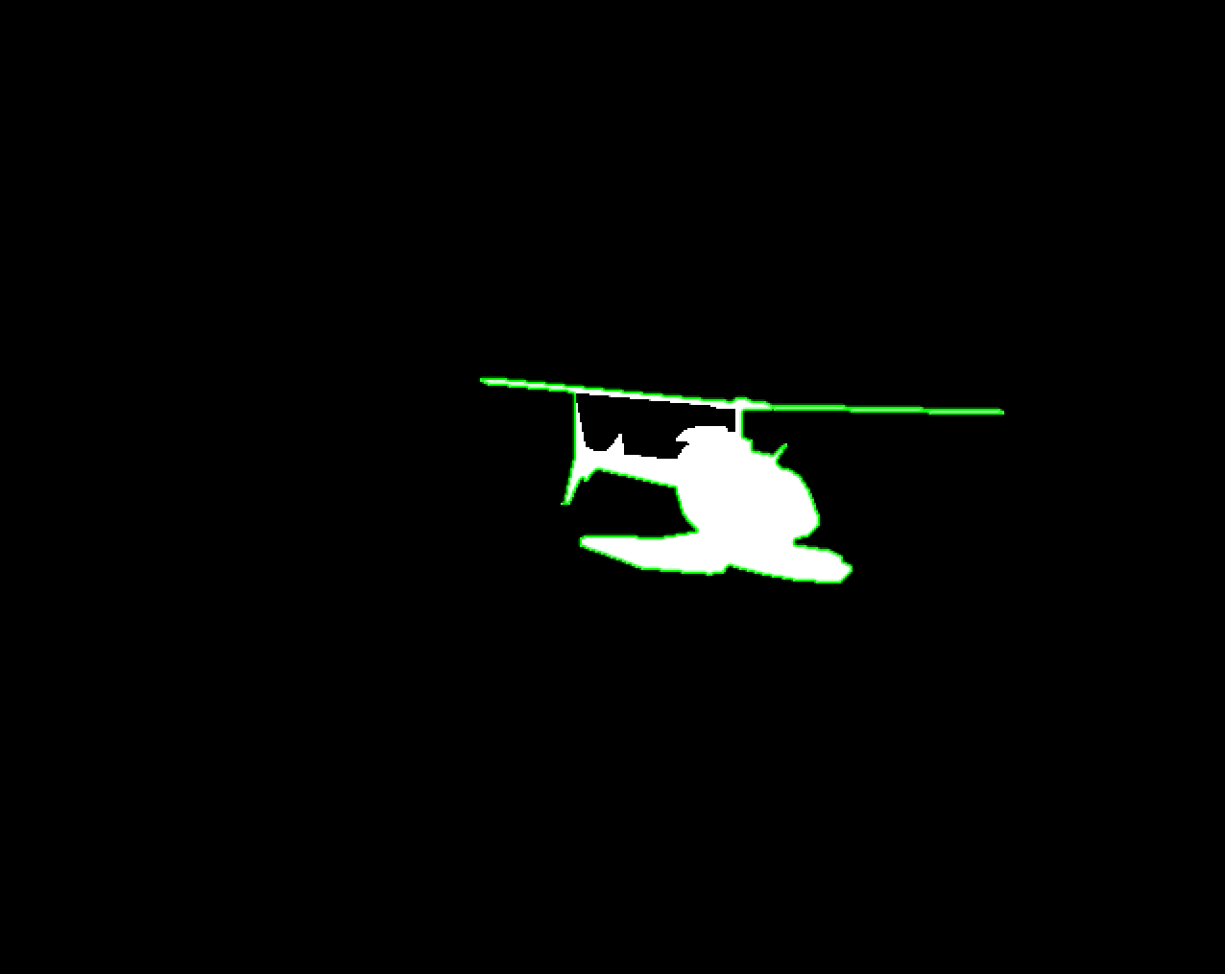

Issues:

